How often are Nepali batters dismissed via run-out?

At first glance, it seems as if Nepali batsmen have a habit of getting themselves run out. And an ardent Rhinos supporter would go so far as to say – Nepali batsmen run themselves out far too often.
However, when examining the data for T20I matches played in 2025, the Nepali team tends to get opposition batsmen run out far more often than their own batsmen are run out.
They’ve found their batters being run out in 7 matches, and a total of 9 times, from the 16 completed matches in 2025. They’ve had two dismissals to run out twice in a match, once with Scotland and the other in the third T20I against the West Indies, and they’ve gone one to lose both matches.
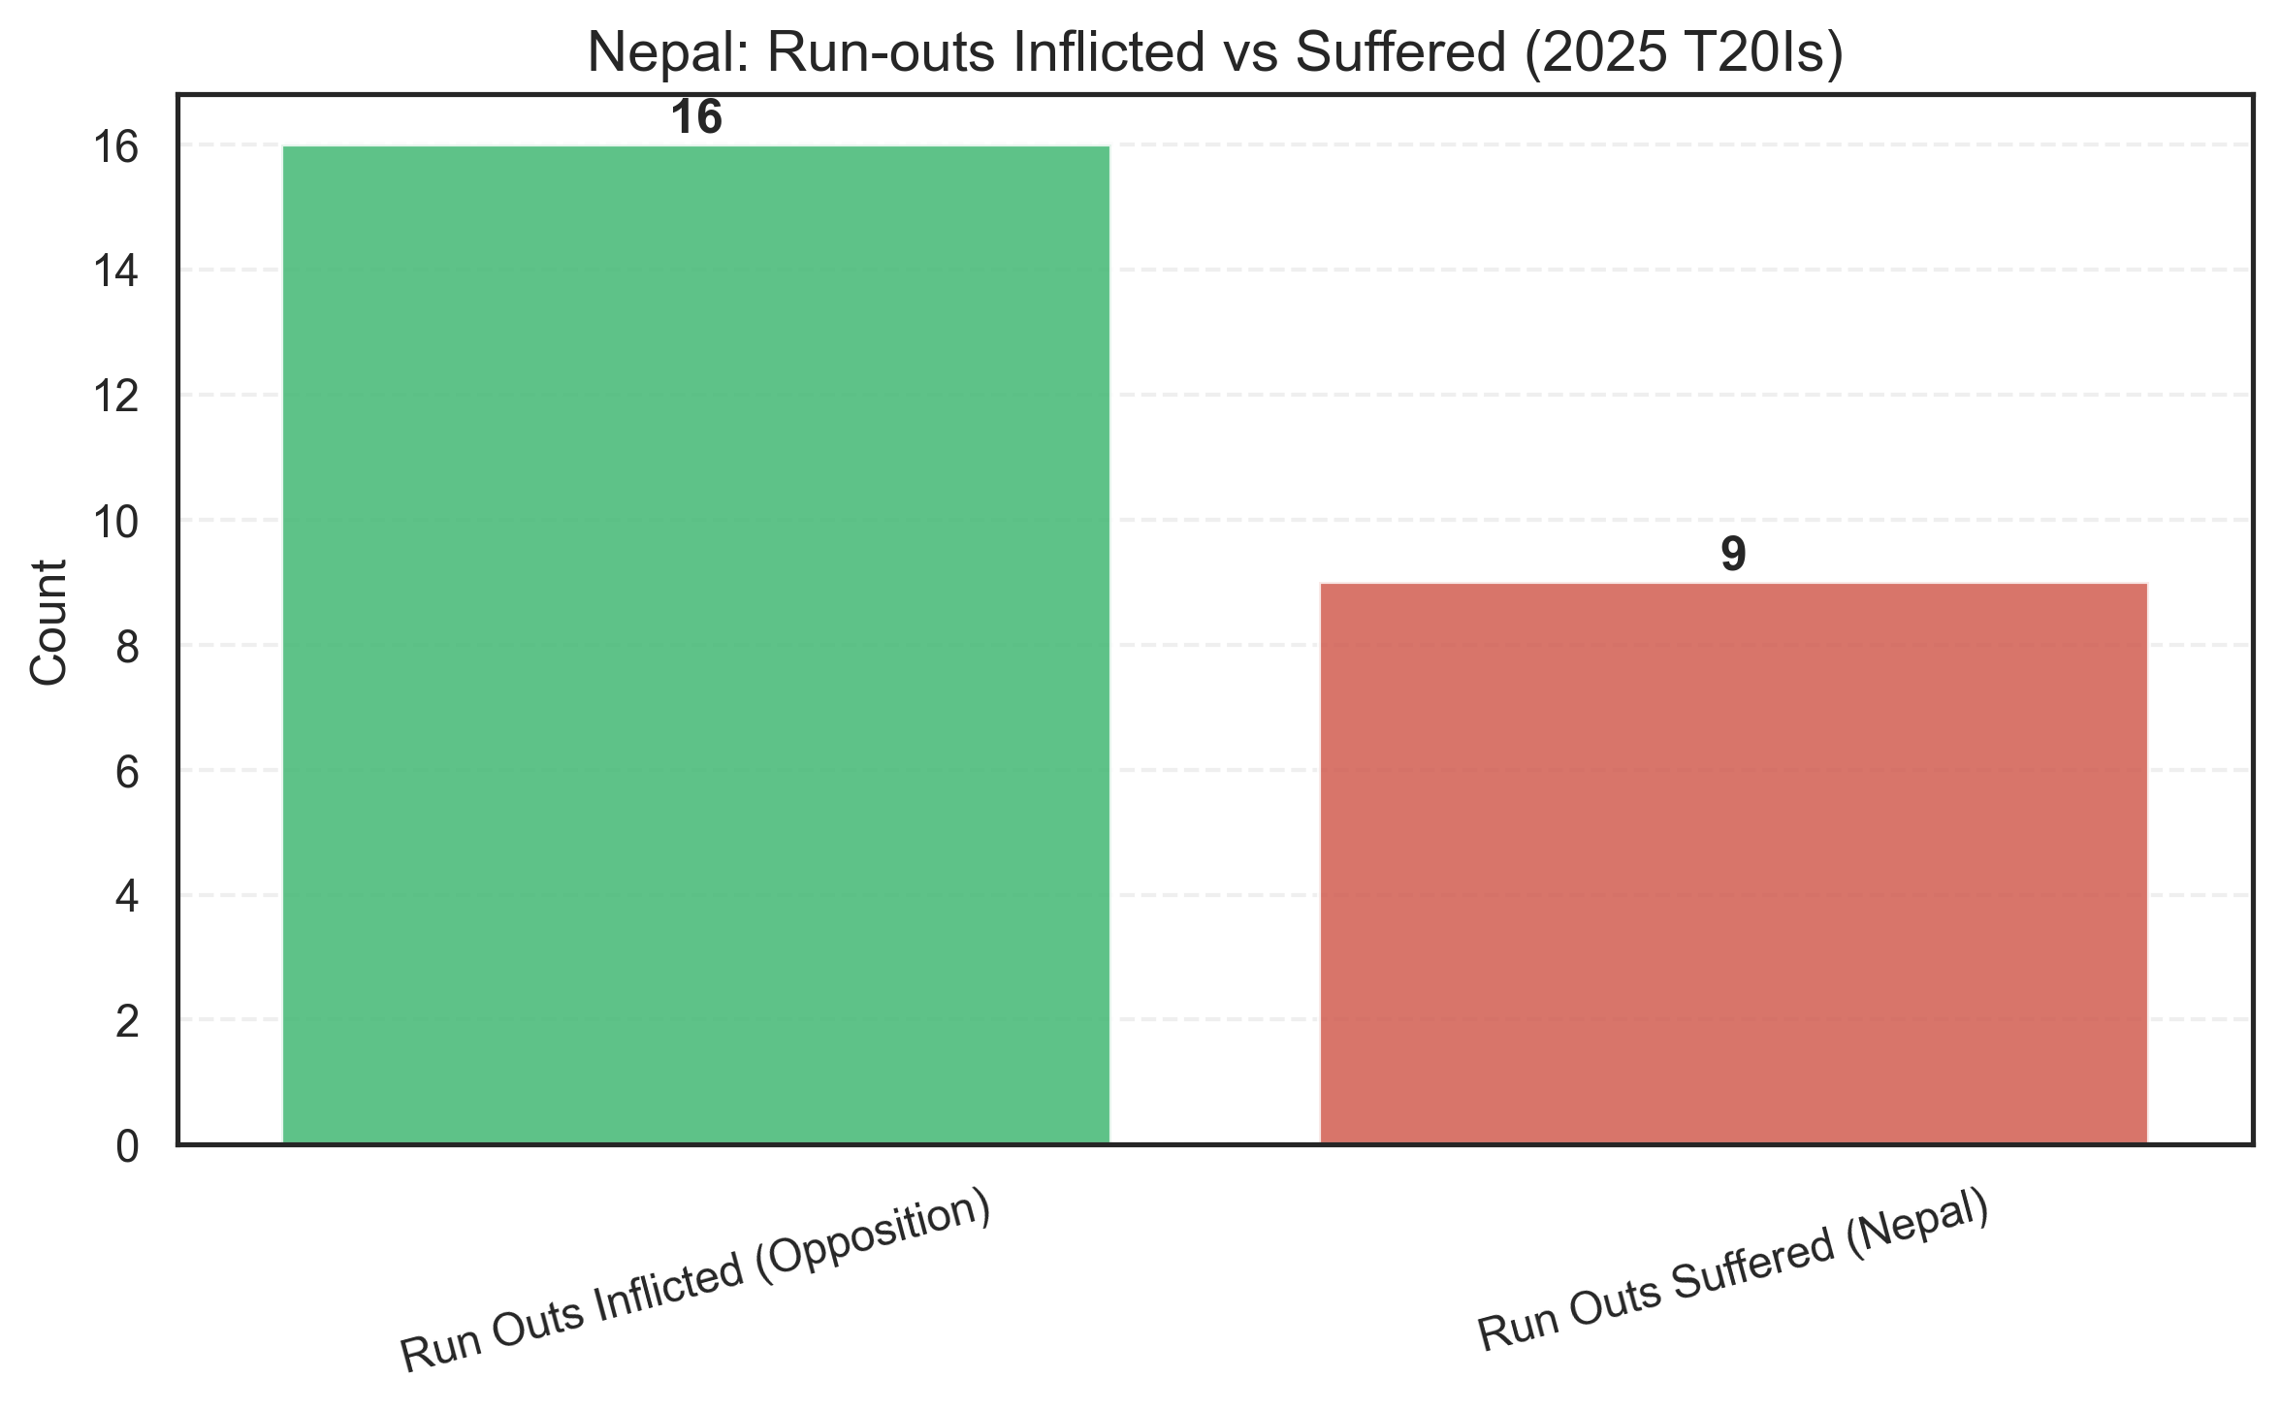
Win-loss ratio when run outs have occurred :
Out of the 7 matches, Nepal have lost 3 and won 4, and the two losses have come when they’ve lost more than one wicket to run out.
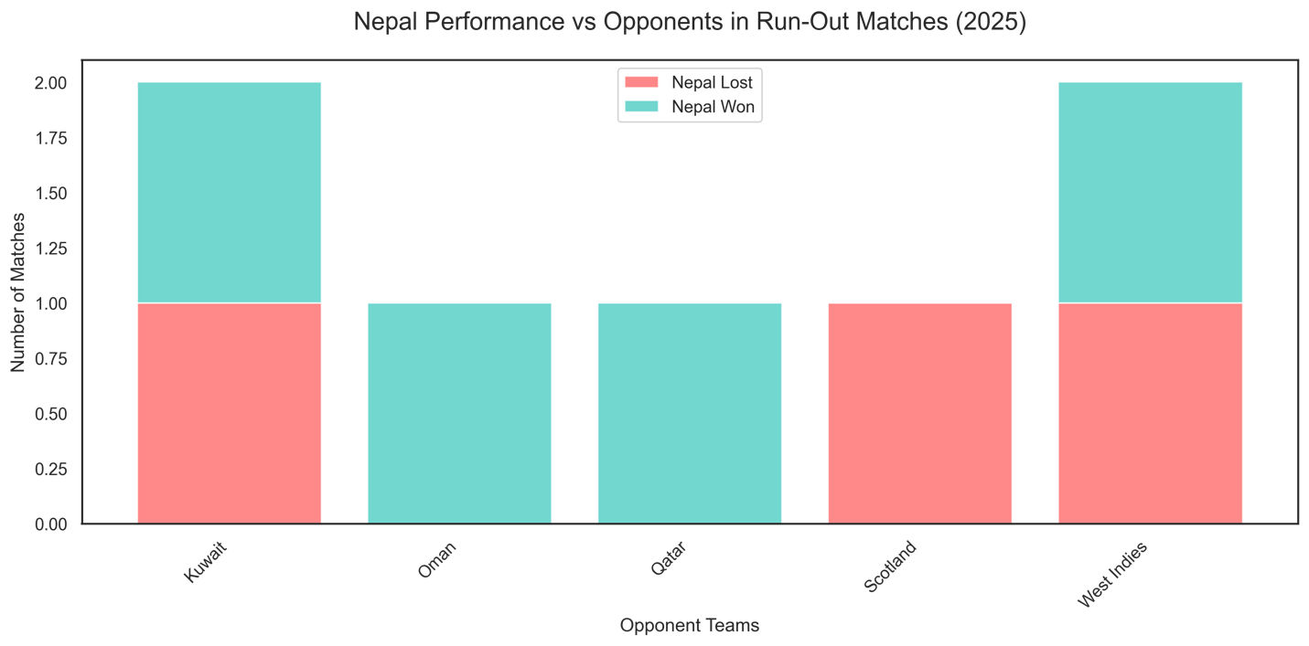

How much better was Nepal at inflicting run-outs compared to being dismissed by run-out in 2025?
Percentage Difference=(16−9) /9= 0.78
Nepal produced roughly 78% more run-outs than they suffered.
Order of batsmen run out
It was mostly the batsmen in the lower order (9 to 11) and Lower middle order (7 and 8) that were run out 5 times in total. Given that lower-order batsmen often look for quick runs and are not traditionally strong runners, this is expected. Only once in the 16 innings was a top-order batsman run out, and 3 times were the middle-order batsmen run out.
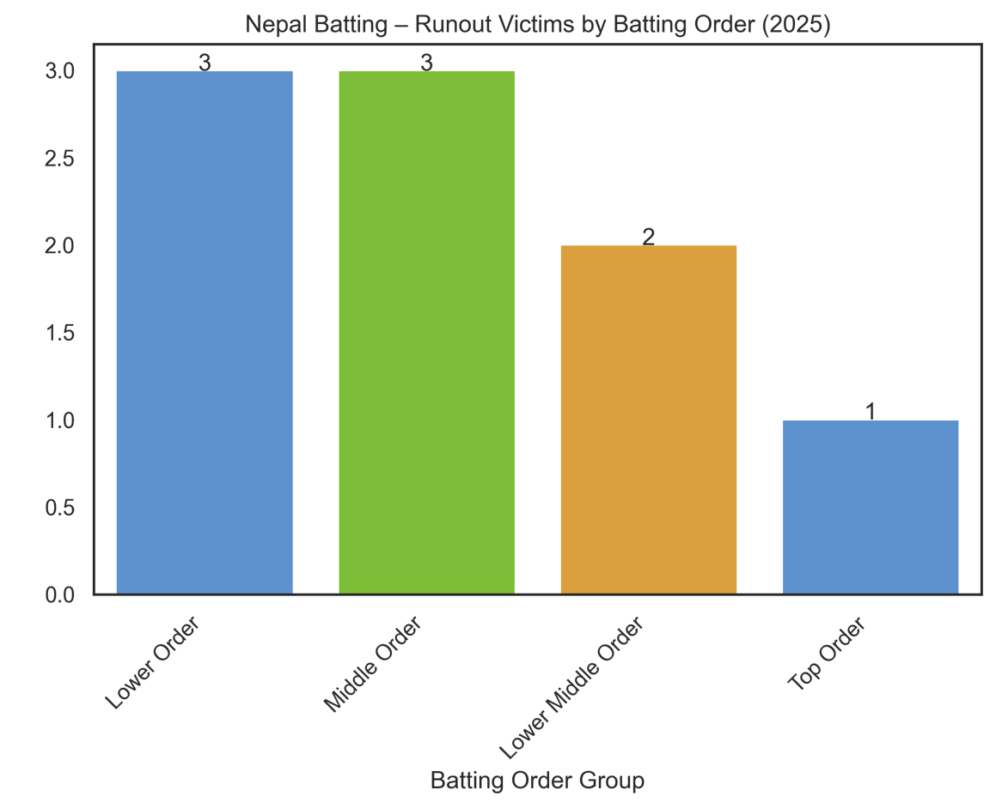
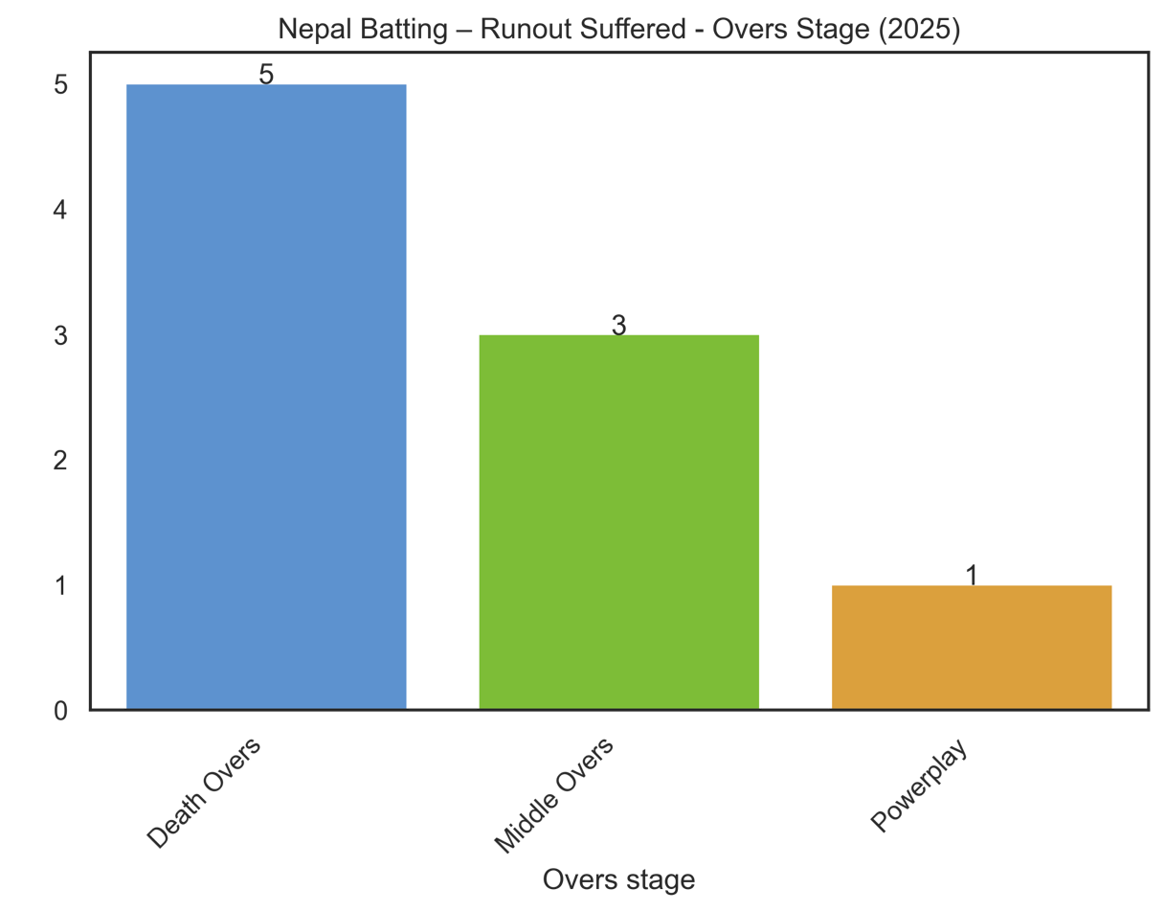
Ultimately, the data suggests, the Nepali batters aren’t reckless runners between the wickets as it can so often seem.

